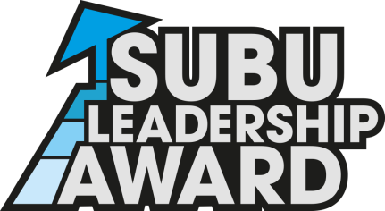
Level 5 Report

Name:…………………………………………………………………………
BU Email Address:………………………………………………………
SUBU Leadership Role:……………………………………………….

Please write in approx. 1000 words a reflective report for the activity you led and include the following information:
- An overview of how the activity went
- The skills required and used during the activity
- The feedback you received from the event
- What measures you used to make your event ethical and environmentally sound
- Any challenges you faced and how you overcame them
- Anything you would have done differently
- How this experience has helped you to develop as a Leader
(Please use a continuation sheet if necessary)

